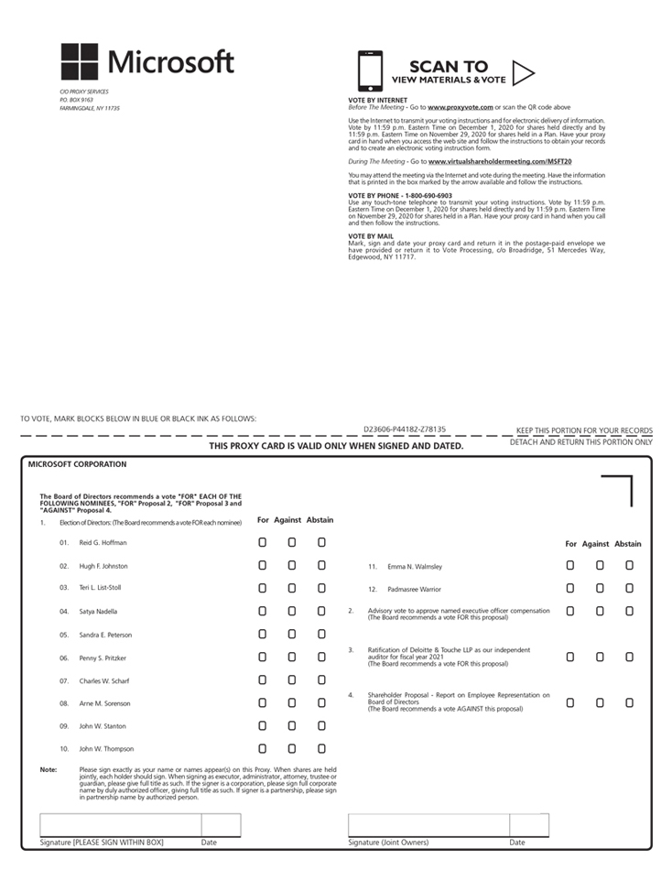

C/O PROXY SERVICES P.O. BOX 9163 FARMINGDALE, NY 11735 SCAN TO VIEW MATERIALS & VOTEVOTE B